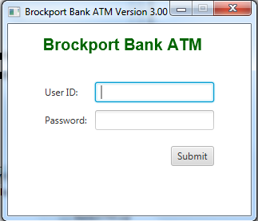

**Login Screen: Code provided by Oracle**

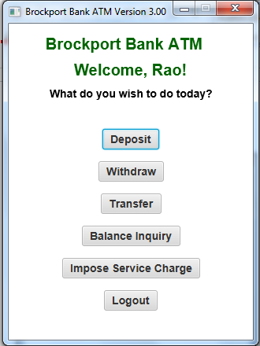

**Main Menu Screen – Designed by instructor**

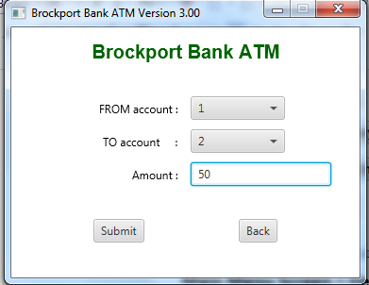

**One of the Transaction screens (Transfer Money) – designed by instructor keeping HCI recommendations in mind. For example, the labels for each control (e.g., “FROM account:” are FLUSHED RIGHT). The two buttons ‘Submit’ and ‘Back’ are separated by some significant whitespace.**

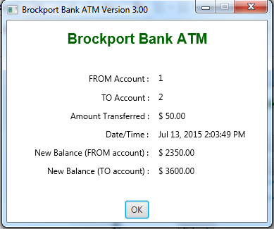

**One of the Transaction Receipt screens – designed by instructor. Again, note the HCI issues kept in mind – the designer has flushed the labels on the left to the right, and printed the date in US format (if doing this in French, it would have to be different). Same with currency display.**

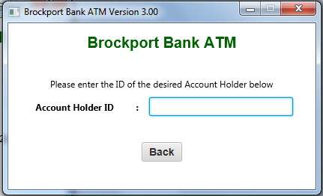

**The first screen of another transaction – designed by instructor. Its appropriateness to be discussed (e.g., do you need a SUBMIT button?)**

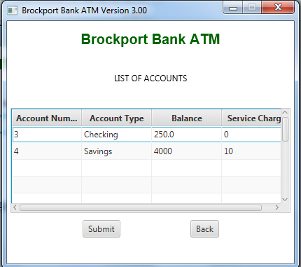

**Screen that shows a TABLE with Account data – one of these accounts will be selected for imposing a service charge manually. On this screen, note that that the user can select the account by either single clicking a row and then hitting the SUBMIT button or by double clicking the row.**

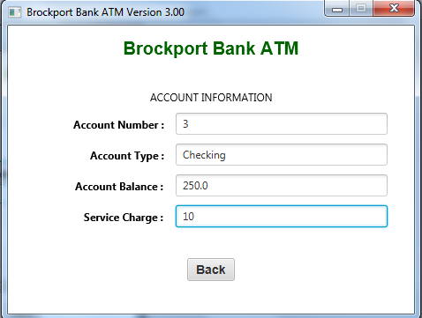

**Screen to actually enter the service charge to impose. Again, where is the SUBMIT button?**

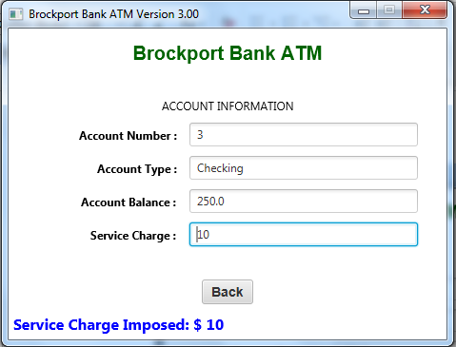

**After hitting the ENTER key on the above screen, the screen is updated with a message that would possibly need to be internationalized.**

**The BACK button would take you back to the Main Menu screen as this transaction is now complete.**